**CLASS ATTENDANCE SYSTEM USING FACIAL RECOGNITION**

**Abstract**

The aim of this project is to design and implement a class attendance system using raspberry Pi. The goals will be accurate detection students faces, creating a record and/or updating existing records with images captured from a camera attached to the raspberry Pi.

**Introduction**

 A Cyber Physical System is typically designed as a [network](https://en.wikipedia.org/wiki/Computer_network) of interacting elements with physical input and output instead of as standalone devices and the notion is closely tied to concepts of [robotics](https://en.wikipedia.org/wiki/Robotics) and [sensor networks](https://en.wikipedia.org/wiki/Sensor_network) with intelligence mechanisms proper of computational intelligence leading the pathway.

Here we implemented such a networked system where we used the raspberry pi to act as both an input and output system remotely connected to a computer and used a camera as our sensor

The real time class attendance system with face recognition system is our take on connecting the class attendance to the Internet. It generates a conventional looking class attendance detailing the exact time a student did appear in class as well as possess the ability to send such an attendance to whoever is authorized to view it.

**Motivation**

In this project we were asked to build a system using a microcontroller (Arduino/ Raspberry Pi) and sensors. The main focus of this project was to build a system through which we can replicate the mechanisms of embedded system. Besides, the project goal was to make us realize the distinct engineering techniques which are inevitable to design and analyze any particular system.

We wanted to come up with a system which can deliver a cost-effective solution to a real world problem. There were many existing issues which we wanted to choose such as Arduino based GSM home security, smart receptionist with a smart lock system, soccer robot, solar tracker system and so on. But we also had to consider time and cost constraint. We had to take several decisions prior deciding our project. Such as:

1. Does the project fulfill all the requirements?
2. Would we be able to deliver the project in a timely manner? To answer this question we had to analyze the following issues:
3. Do we have required skills to pull off a particular task?
4. Expenses related to the physical equipment.
5. How long it would take to receive the equipment?
6. Is our solution cost effective?

Based on all these fundamental criteria we decided to build a face recognition system based on raspberry pi. One of group members grew up in a south Asian country. There were approximately 120 students in a single class room. The teacher used to call the name of each students which took out 20 minutes in hourly session. In some cases the process was repetitive for each class. This is quite common throughout all the south Asian schools and colleges. We could imagine the amount of precious learning time lost by the students in that region.

We have another group member who grew up in Texas. He experienced a better system than students in South Asia. Each of his classroom has a RFID card reader which keeps track of the students attending the class. However, he also faced significant delays where he had to wait in long que of line along with his other classmates prior entering the classroom. Compared to the to the previous manual roll call system the RFID card scanner was better but certainly nowhere near to the optimum solution.

Once we came across this idea we did a market research on similar face recognition systems which are available in the market. The price range for the cheapest camera starts from S90 and goes up to $1600. Where as we have only spent 42 dollars in coming up with a consistent face recognition system using raspberry pi with the possibility of the price dropping to as low as $22 when we choose to implememt the system with a cheaper raspberry pi system.

Tasked with a challenge to design cyber physical system with limited time and cost constraints we considered several existing issues such as Arduino based GSM home security, smart receptionist with a smart lock system, soccer robot, solar tracker system among others. Factoring in the following considerations

1. Does the project fulfill all the requirements?
2. Would we be able to deliver the project in a timely manner? To answer this question we had to analyze the following issues:
3. Do we have required skills to pull off a particular task?
4. Expenses related to the physical equipment.
5. How long it would take to receive the equipment?
6. Is our solution cost effective?
7. Can we improve upon existing solutions?
8. Will the final product have a market value?

Based on all these fundamental criteria we decided to build a face recognition system based on raspberry pi as successful creation of such a system would meet achieve all our desired goals.

Project Vision

Real Time CLASS ATTENDANCE Face Recognition System is a simple, unobtrusive class attendance system capable of generating student’s attendance in Realtime. The vision was to design such a system that could generate an accurate class attendance only with the aid of a raspberry pi and a camera and be able to remotely transmit such information to intended parties via the internet.

Hardware components

Table 1 below list the hardware components used in the system. It was categorized into input, output, system power and others. A sample of the connected system is shown on figure 1

|  |  |
| --- | --- |
| Category | Components |
| Input (Sensor) | Camera |
| Output | Monitor |
| System | Raspberry Pi 3  Apple Laptop |
| Power | 5-10 A power supply |
| Other | HDMI cable  TTU university internet services |

Table 1 List of Hardware Components

Diagram here

**Figure 1 diagram of connected system**

**Software Components**

Software components could be divided into two broad categories. The facial recognition application and the interface application.

The facial recognition Application:

This was designed with the aid of opencv in a python environment. Opencv 3 was used hence the system must be able install install the necessary files for a susccesfful development.

The designed system when activated using the interface application would run a recursive operation in the targeted folder such as figure 2 to capturing the faces of students in the such a folder, and then using the captured images to recognize students faces as shown in figure 3 to generate a record of students attendance within an earlier specified time interval.

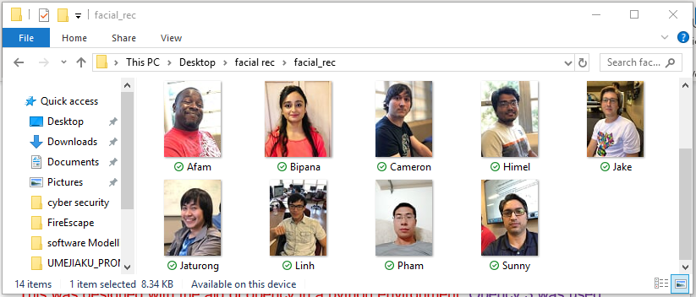

Figure 2. Sample folder containing students faces

PLEASE INSERT PICTURES NOT RUNNING IN MY SYSTEM

Figure 3. the system capturing students faces

The Interface Application:

The interface application as shown in figure 4 was used to input the name of the class as well as the time period the program shown run. After inserting the class details and the time period the start button will be activated. Only upon clicking an activated start button will the facial recognition application be activated as well as the camera. A sample of the records generated is shown in figure 5

PLEASE INSERT PICTURES NOT RUNNING IN MY SYSTEM

Figure 4. The application Interface

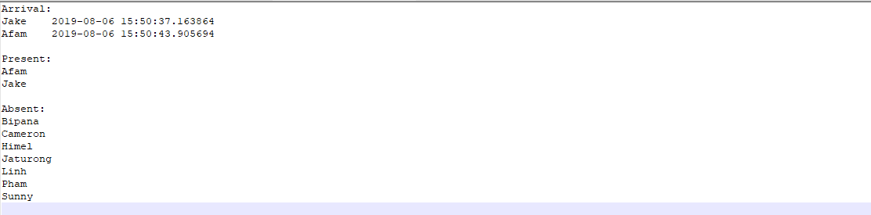

Figure 5. Sample of Class attendance records

**Demonstration and improvements.**

As demonstrated on presentation day we were able to show that our design concept was feasible as the system was able to develop students class attendance. After the official demonstration we developed an interface to make the Design more user friendly.

**Finite State machines**

Here the various states of the system is modelled with Figure 6 showing the modeling of the Interface and figure 7 showing that of the Facial recognition system. The complete modelling of the system is shown in figure 8.

Figure 6GUI STATE PROGRAM

Figure 7FACIAL RECONGITION PROGRAM

Figure 8

**Challenges and Solutions**

In the execution of the project, among other challenges the most prominent were -

1. Developing the facial recognition application in Python environment capable of running on raspberry pi was difficult as the system did not meet the requirements earlier specified.
2. Time period offered was insufficient for us to complete the prototyping of the concept and the develop a compiled solution that would run across any platform.

As a result, the facial recognition application was designed capable of running only in systems that meet the needed requirements while the interface allowed a user control the system either directly from the raspberry pi or a laptop. This solution we later discovered gave the system more value as it meant that one could use any wireless camera and a laptop to produce students attendance based on our design.

**Future Work**

Currently we are working on developing an attendance system in C that we can compiling capable of running across various platforms having seen our design cost a fraction of the cheapest solutions in the market.

**Conclusion**

This report explains the motivation for the project, the components that were used, they design process in developing a software that can perform facial recognition with the aid of Opencv in a python environment and the steps taken to used the design software to take attendance of students as the appear in class during a specified time period. The state transitions diagram shows the conditions that must be meet for a student in the attendance list to be moved from one state to another. The interface was designed to allow a teacher/lecturer to set the state conditions, modify the class list and view the result with those that meet the conditions marked present and others marked absent.